1. Write an HTML page like the following:

\* Use headings and divs  
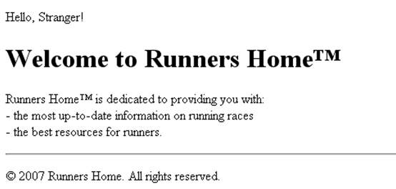

1. Write an HTML page like  
    the following:  
     
   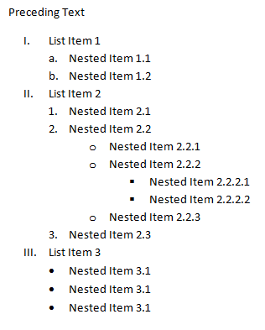
2. Create an user profile Web page Profile.html, friends page named Friends.html and info page named Info.html. Link them to one another using <a> tag  
     
     
   